DELHIVERY FEATURE ENGINEERING & LOGISTICS ANALYTICS REPORT

1. Executive Summary
This project focuses on transforming raw logistics shipment data from Delhivery into a structured analytical dataset suitable for forecasting, operational optimization, and future machine learning applications. The original dataset consisted of shipment-level and segment-level records, where a single shipment could span multiple transportation segments.
The project involved data cleaning, aggregation, feature engineering, exploratory data analysis, hypothesis testing, outlier treatment, categorical encoding, and feature scaling. Through statistical analysis and business-focused exploration, several operational inefficiencies were identified, including significant differences between actual delivery times and OSRM route estimates, high-delay logistics corridors, and substantial variability in delivery performance.
The final output is a machine-learning-ready dataset enriched with engineered features and actionable business insights that can support ETA prediction, route optimization, and logistics planning.

2. Problem Statement
Delhivery generates large volumes of logistics movement data through its transportation network. Since shipment information is distributed across multiple route segments, direct analysis of the raw data does not provide meaningful business insights.
The objective of this project was to:
- Aggregate segment-level records into trip-level observations.
- Create useful features from raw operational data.
- Validate relationships between route estimates and actual delivery performance.
- Identify delivery bottlenecks and inefficiencies.
- Prepare the dataset for future forecasting and machine learning applications.

3. Dataset Understanding and Initial Exploration
The dataset contained 144,867 records and 24 features related to shipment movement, route estimates, actual delivery performance, and transportation routes.
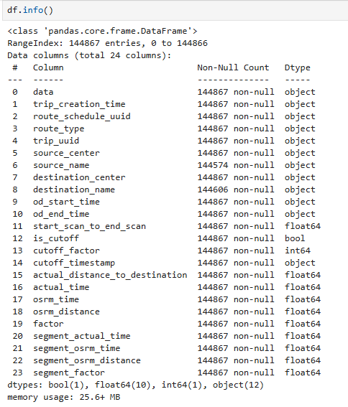
Initial exploration was performed to understand:
- Dataset dimensions
- Feature types
- Missing values
- Data quality issues
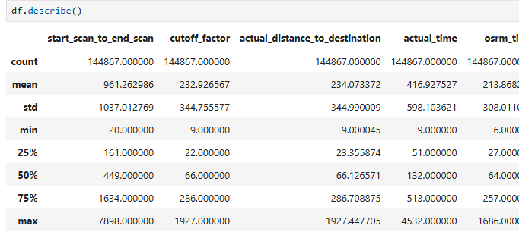
- Aggregation requirements

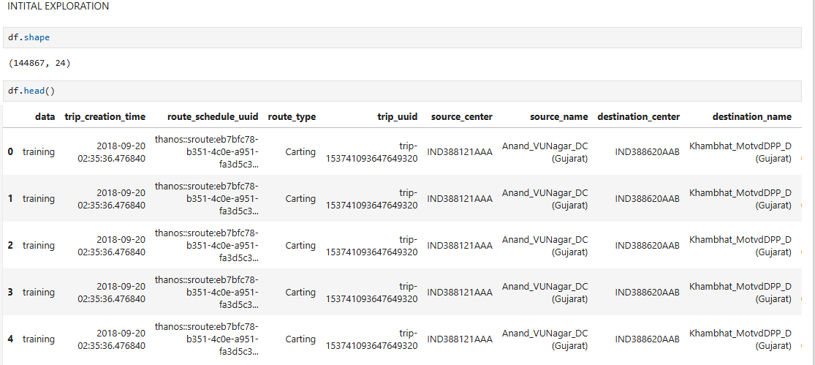

Observations
- The dataset contained both numerical and categorical features.
- Several datetime variables required conversion before analysis.
- Shipment records existed at the segment level, requiring aggregation before business-level analysis could be performed.

Insight
The structure of the dataset confirmed that feature engineering and aggregation would be essential before any meaningful analytical work could begin.

4. Data Cleaning and Preprocessing
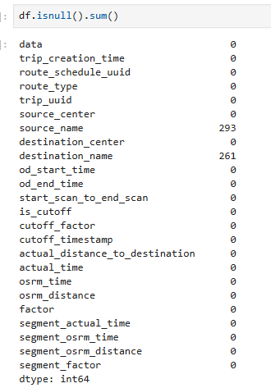
The first stage of preprocessing focused on identifying missing values and validating data quality.
Missing value analysis revealed:
- source_name: 293 missing values
- destination_name: 261 missing values
The percentage of missing observations was relatively small compared to the overall dataset size.
Datetime conversion was performed on:
- trip_creation_time
- od_start_time
- od_end_time
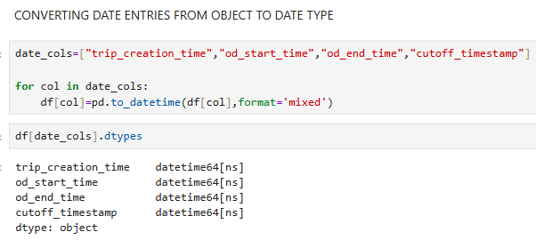
- cutoff_timestamp

Observations
- Missing values represented a very small portion of the dataset.
- Datetime conversion enabled the creation of operational duration features.
- Data quality was generally good, requiring minimal cleaning.

Insight
The dataset was sufficiently complete to proceed with aggregation and feature engineering without significant information loss.

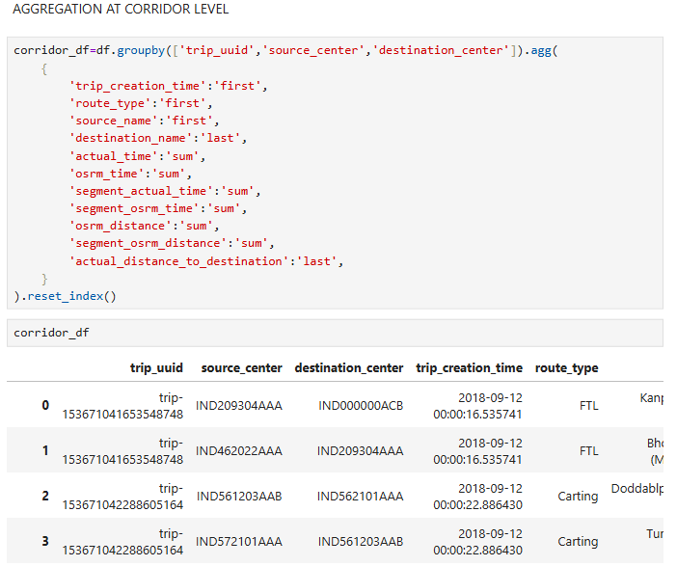
5. Aggregation Strategy
Since a single shipment may contain multiple route segments, aggregation was necessary to create trip-level observations.
Aggregation was performed in two stages:

Stage 1
Grouped by:
- trip_uuid
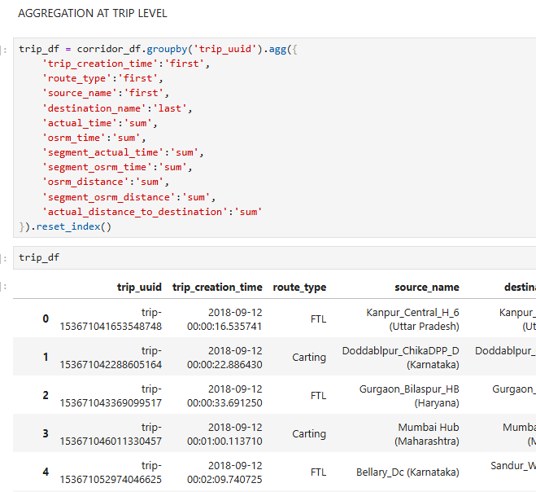
- source_center
- destination_center

Stage 2 (144,867 to 14807 records)
Further aggregated by:
- trip_uuid
Numerical variables such as actual_time, osrm_time, and distance-related metrics were aggregated using summation, while categorical variables used first or last occurrences depending on business relevance.

Observations
- The dataset was reduced from 144,867 records to approximately 14,807 unique trips.
- Aggregation successfully consolidated fragmented shipment information.

Insight
Trip-level aggregation enabled accurate measurement of delivery performance, route efficiency, and corridor-level operational behavior, which would not have been possible using the raw segment-level data..

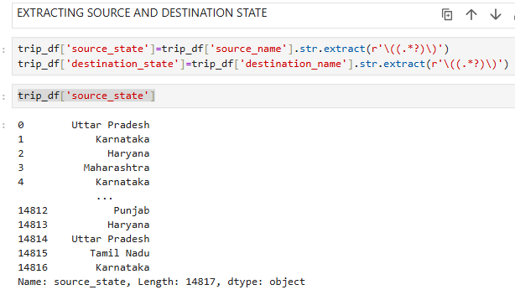
6. Feature Engineering
Several new features were created to enrich the dataset.

Location-Based Features
Extracted:
- Source State
- Destination State
Time-Based Features
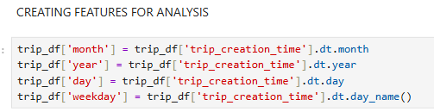
Derived:
- Month
- Day
- Year
- Weekday

Operational Features
Created:
- OD Duration
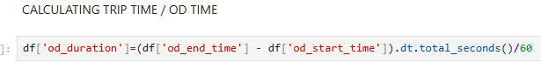
- Corridor Feature

Observations
- Feature engineering transformed raw location strings into meaningful business attributes.
- Time features enabled temporal analysis.
- Corridor creation enabled route-level performance evaluation.

Insight
The newly created features enabled identification of shipment concentration patterns, route-level bottlenecks, and state-to-state corridor performance..

7. Validation of Operational Duration Metrics
A new feature called OD Duration was created using od_start_time and od_end_time.
The objective was to compare this engineered feature with start_scan_to_end_scan to determine whether both variables represented similar operational processes.
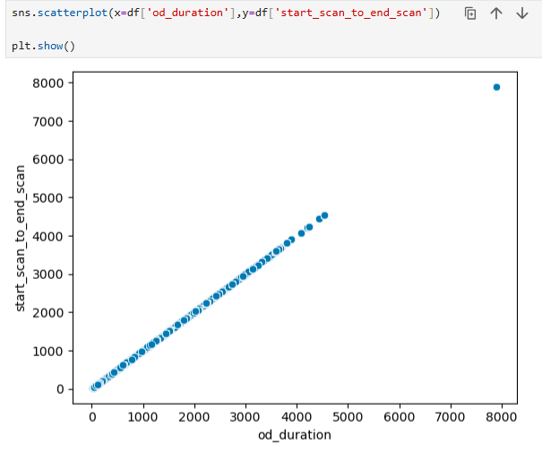

Observations.
- The scatter plot demonstrates a near-linear relationship between the two variables, indicating strong consistency between independently recorded operational timestamps.

Insight
The close alignment confirms that OD Duration is a reliable representation of actual shipment movement duration and can be confidently used in downstream analysis and predictive models.

8. Actual Time vs OSRM Time Analysis
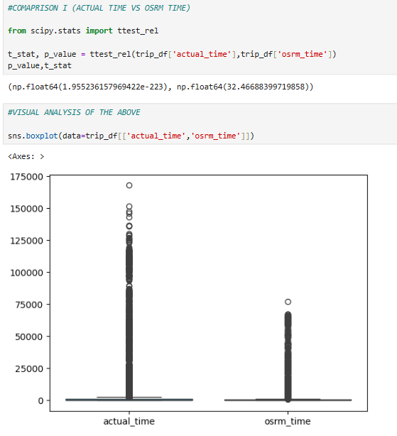
One of the primary objectives of the project was to evaluate the difference between actual delivery performance and route estimates generated by OSRM.
A paired hypothesis test was conducted.

Findings
- Actual delivery times were significantly higher than OSRM estimated times.
- Statistical testing confirmed that the difference was highly significant.

Observations
- Actual delivery time averaged 4,078 minutes which is approximately 95% higher than OSRM estimated times on average.
- The boxplot comparison shows that actual delivery times exhibit significantly greater variability and more extreme delays than OSRM estimates

Insight
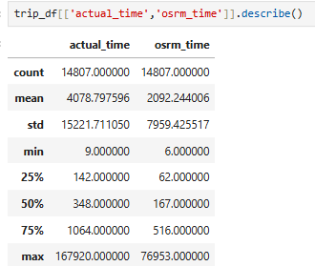
Route travel time alone does not explain delivery performance. Operational delays such as loading, unloading, hub processing, and waiting periods contribute significantly to overall delivery duration.

Statistical Results
- Mean Actual Time = 4,078.8 minutes
- Mean OSRM Time = 2,092.2 minutes
- Difference = 1,986.6 minutes
- T-statistic = 32.47
- P-value = 1.95 × 10⁻²²³

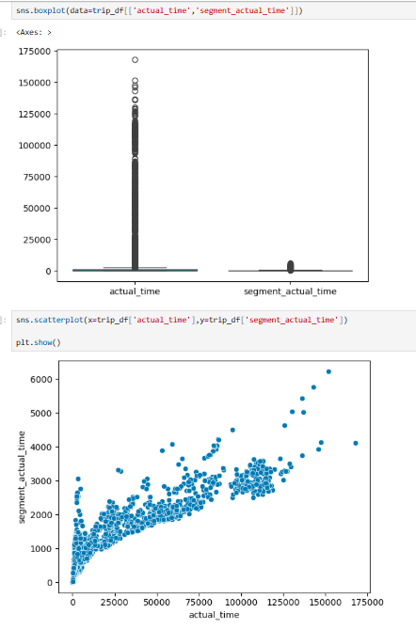
9. Actual Time vs Segment Actual Time Analysis
The relationship between trip-level delivery duration and segment-level delivery duration was evaluated.

Findings
- Strong positive correlation was observed.
- Statistical testing indicated a significant difference between the two measures.

Observations
- A correlation of 0.875 indicates a strong positive relationship between segment movement duration and total trip duration.
- However, the significant hypothesis test result indicates that total delivery duration includes substantial additional operational time beyond pure transportation movement.

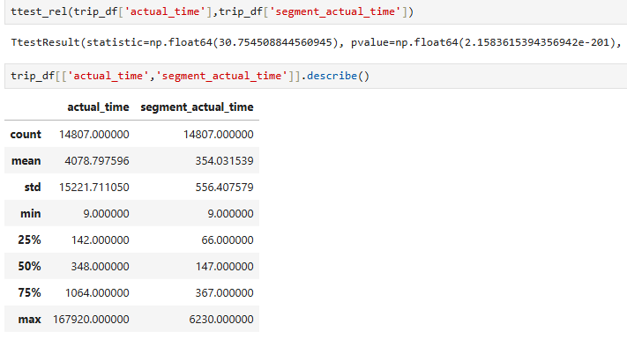
Insight
Movement time alone is insufficient for accurate ETA prediction. Operational process metrics should also be incorporated into forecasting models.

Statistical Results
- Correlation = 0.875
- T-statistic = 30.75
- P-value = 2.16 × 10⁻²⁰¹

10. OSRM Distance and Time Consistency Analysis
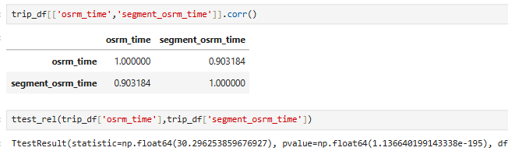
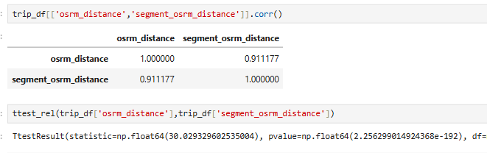
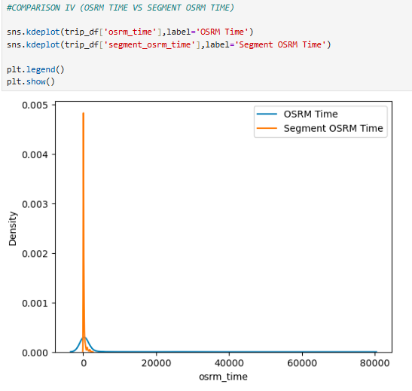
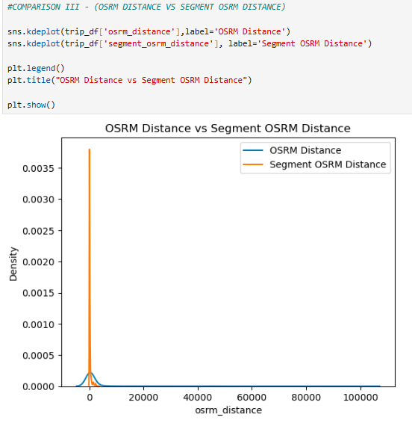
Route-level and segment-level OSRM estimates were compared to validate aggregation quality.

Findings
- Strong correlations were observed for both distance and time metrics.
- Aggregation preserved route-level information effectively.

Observations
- Segment-level estimates closely matched aggregated route-level estimates.
- Data consistency was maintained throughout the aggregation process.

Business Insight
The aggregation strategy was successful and produced reliable trip-level metrics.

11. Distribution Analysis and Outlier Investigation
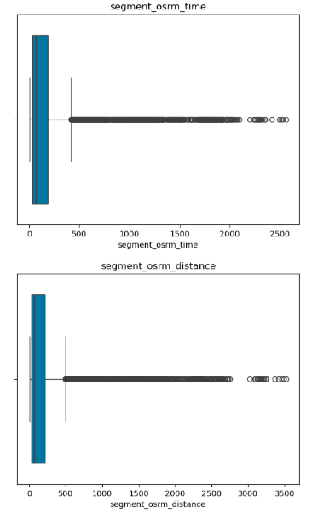
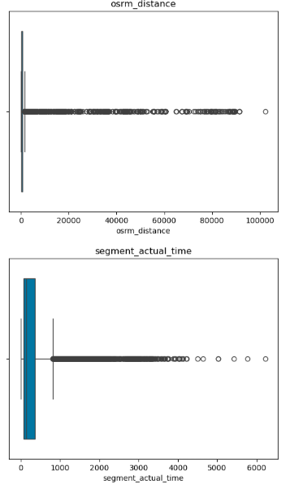
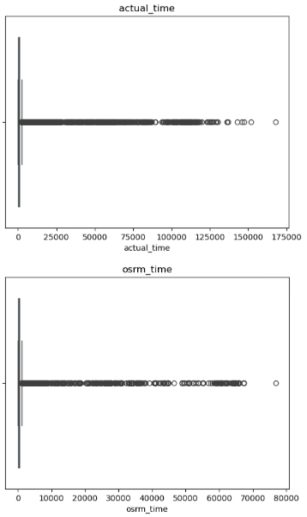
Boxplots were used to study numerical variables.

Observations
- Most time and distance variables exhibited strong right skewness.
- A small number of trips experienced extremely large delivery durations.
- Significant variability existed across shipments.

Insight
While most deliveries were completed within expected durations, a subset of shipments experienced substantial delays that warrant further operational investigation.

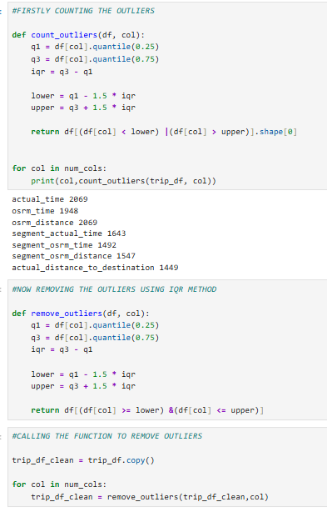
12. Outlier Treatment
Outliers were identified using the Interquartile Range (IQR) method.
Given the highly skewed nature of the variables, IQR was selected instead of Z-score based approaches.

Observations
- Extreme observations were identified across almost all major numerical variables.
- Outlier treatment reduced the influence of unusual deliveries.

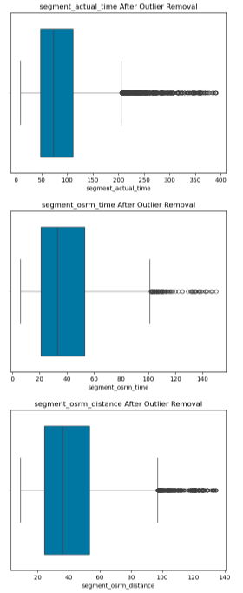
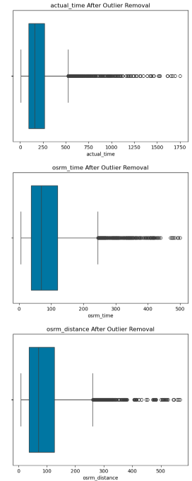

Insight
Removing extreme values improved dataset stability and prepared the data for future machine learning applications.

13. Categorical Encoding and Feature Scaling
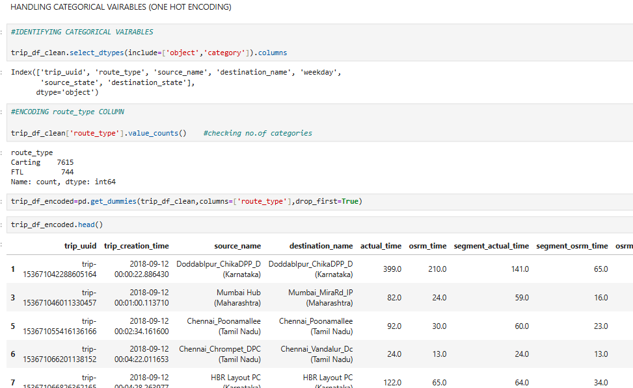
Machine learning algorithms require numerical inputs.

Encoding
One-Hot Encoding was applied to route_type.

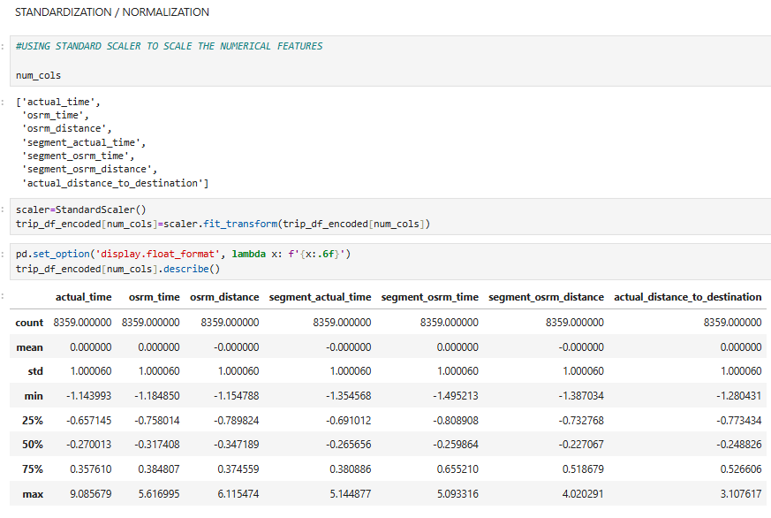

Scaling
StandardScaler was applied to numerical variables.

Observations
- Categorical information became machine-learning compatible.
- Numerical features were standardized to comparable scales.

Insight
The final dataset became suitable for predictive modeling and advanced analytics.

14. Business Insights
Several important operational patterns emerged from the analysis.

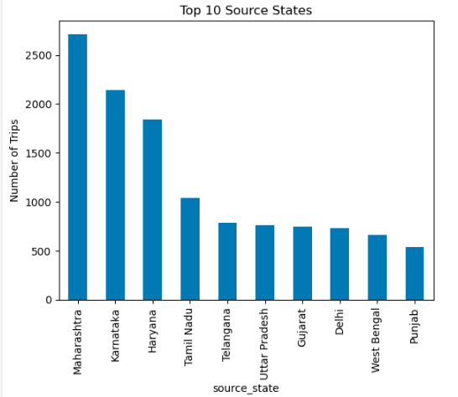
Shipment Concentration
Maharashtra emerged as the largest logistics hub with 2,714 originating shipments, followed by Karnataka (2,143) and Haryana (1,838).

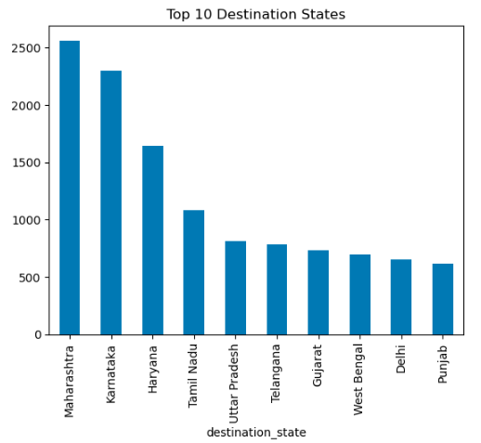
On the destination side, Maharashtra again ranked first with 2,561 shipments, followed by Karnataka (2,294) and Haryana (1,643).

This indicates that western and southern India represent the strongest shipment concentration zones within the network.
.

Corridor Analysis
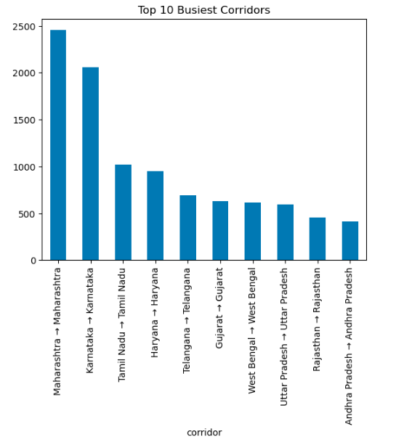

The busiest corridors were primarily intra-state:
- Maharashtra → Maharashtra: 2,453 trips
- Karnataka → Karnataka: 2,057 trips
This suggests that a substantial portion of Delhivery's shipment volume is generated through regional distribution networks rather than long-haul interstate transportation.

Delivery Delays
Actual delivery duration averaged 4,078.8 minutes, compared to an OSRM estimate of 2,092.2 minutes. This represents a 95% increase over estimated travel time and highlights the significant impact of operational processes on delivery performance.

High-Delay Corridors
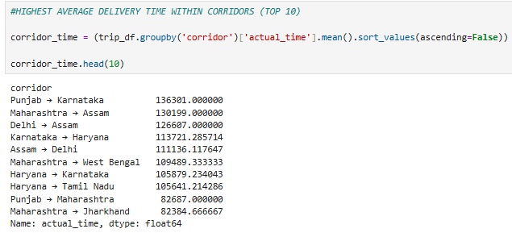

The longest average delivery durations were observed in:
- Punjab → Karnataka: 136,301 minutes
- Maharashtra → Assam: 130,199 minutes
- Delhi → Assam: 126,607 minutes
These corridors represent the most critical operational bottlenecks identified during the analysis.

15. Recommendations
Based on the analysis, the following recommendations are proposed:
• Enhance ETA prediction systems by incorporating historical corridor-level delays, hub processing times, and operational waiting periods.
• Prioritize operational audits for Punjab → Karnataka, Maharashtra → Assam, and Delhi → Assam, as these corridors exhibit the highest average delivery durations.
• Establish corridor-specific SLA targets rather than applying uniform service benchmarks across all routes.
• Develop a shipment-delay monitoring dashboard focused on high-risk routes and recurring outlier deliveries.
• Use the engineered dataset to build predictive delay models capable of identifying at-risk shipments before SLA breaches occur.
• Introduce corridor-level performance benchmarking to continuously measure route efficiency and identify emerging operational bottlenecks.

16. Conclusion
This project successfully transformed 144,867 segment-level shipment records into 14,807 trip-level observations, creating a structured dataset suitable for advanced analytics and machine learning.
Statistical analysis revealed that actual delivery times are approximately 95% higher than OSRM route estimates, demonstrating that operational factors play a critical role in shipment performance.
Correlation analysis confirmed the validity of the aggregation methodology, with route-level and segment-level metrics exhibiting correlations above 0.90.
The study identified Maharashtra, Karnataka, and Haryana as the most significant shipment hubs and highlighted critical bottlenecks in long-distance interstate corridors such as Punjab → Karnataka and Maharashtra → Assam.
Overall, the project demonstrates how feature engineering, statistical validation, and logistics analytics can be leveraged to improve ETA prediction, route optimization, and operational efficiency across large-scale transportation networks.
The resulting dataset provides a strong foundation for future forecasting, route optimization, and machine learning initiatives within the logistics domain.

